**Jenkins installations**

sudo apt-get update

# Install java

sudo apt-get install openjdk-11-jdk

# Install jenkins key file

wget -q -O - https://pkg.jenkins.io/debian-stable/jenkins.io.key | sudo apt-key add -

# Jenkins dependency

sudo sh -c 'echo deb https://pkg.jenkins.io/debian-stable binary/ > /etc/apt/sources.list.d/jenkins.list'

sudo apt-get update

# Install jenkins

sudo apt-get install jenkins

sudo systemctl enable jenkins

sudo systemctl start jenkins

sudo systemctl status jenkins

Then go to AWS console and add port number 8080.

**Unlock Jenkins**

Path -> /var/lib/Jenkins/secrets/initialAdminPassword

sudo cat /var/lib/Jenkins/secrets/initialadminpassword

Copy and paste the password on web administrator password.

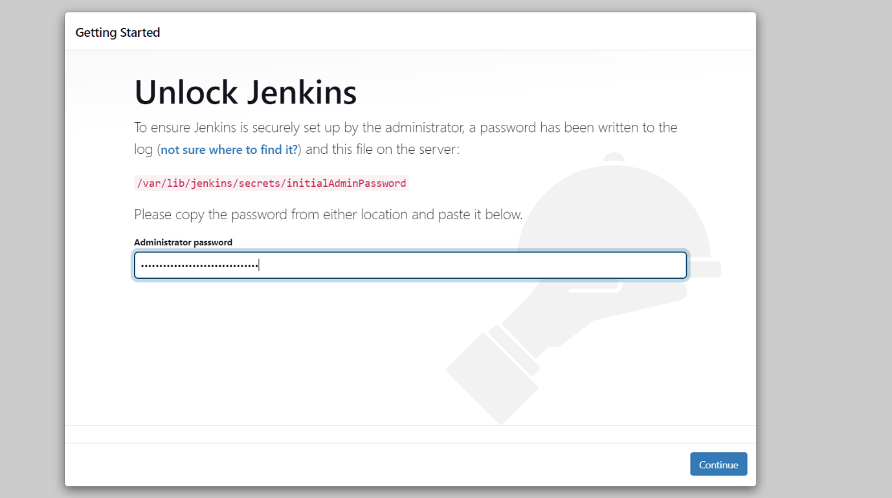

# Select the default plugins

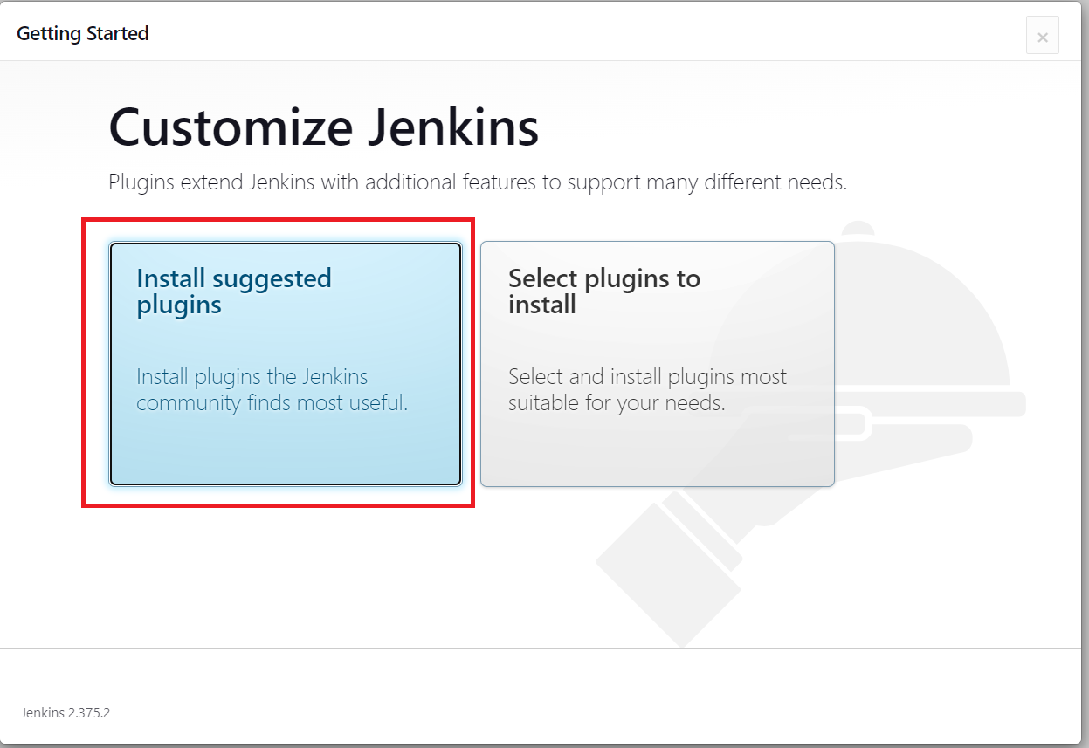

# Create username and password, save and finish.

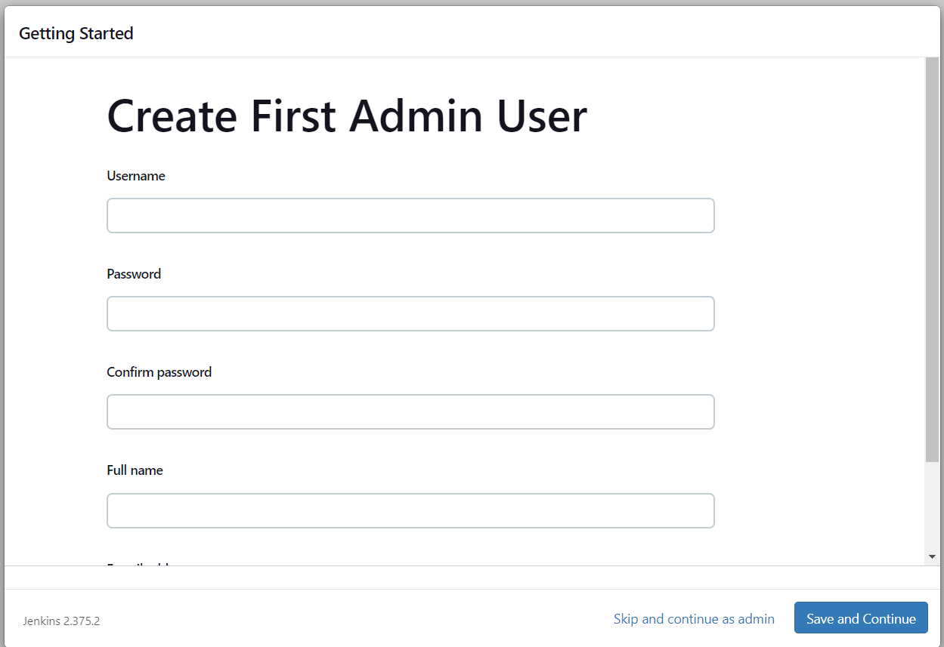

Jenkins -> plugin

- job

- queuing of jobs (upstream & downstream job)

Manual trigger

Time-based/periodic trigger

Remote trigger

Action Based

#Create a new project and go to Build steps then select execute shell

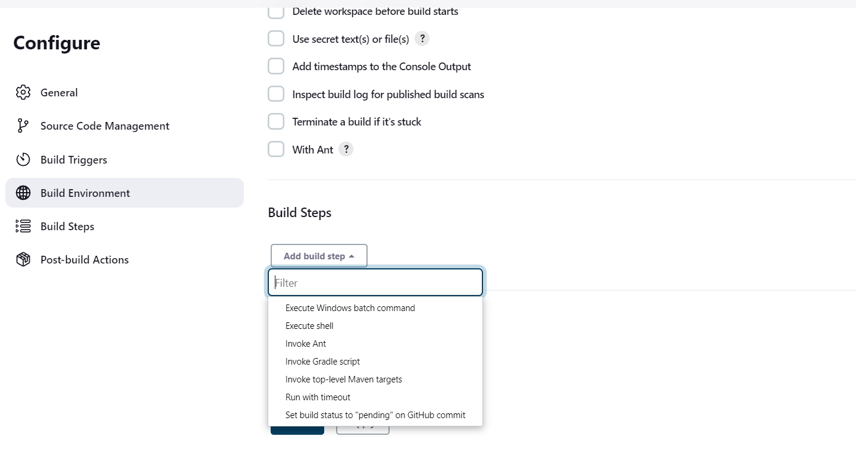

Select manage Jenkins and choose to manage plugins.

Search Role-based authorization plugins, and install without restart.

Go to configure global security

Select manage and assign roles, and assign the roles for users.

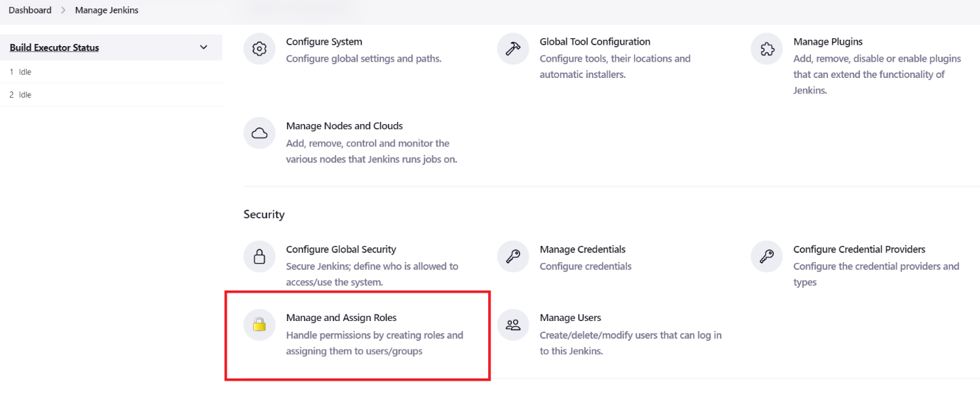

Create global roles

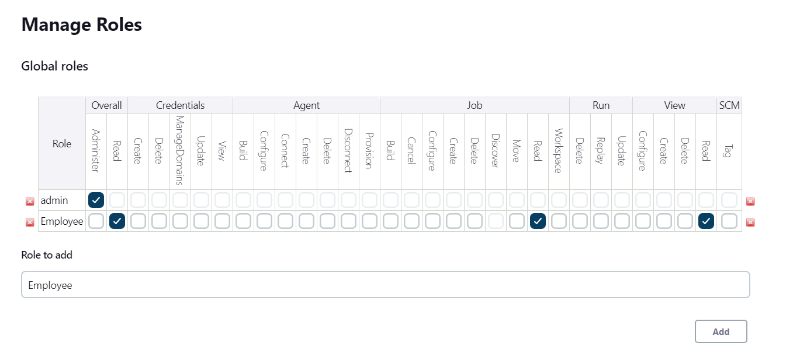

Add item roles

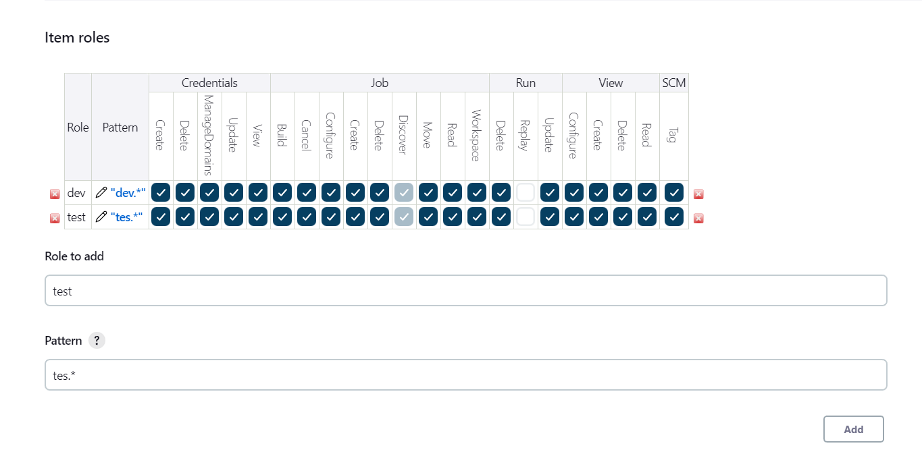

Assign roles

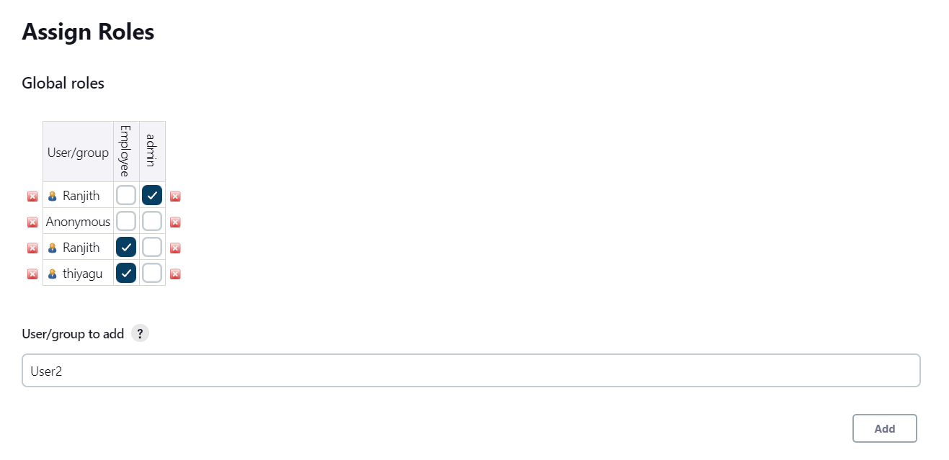

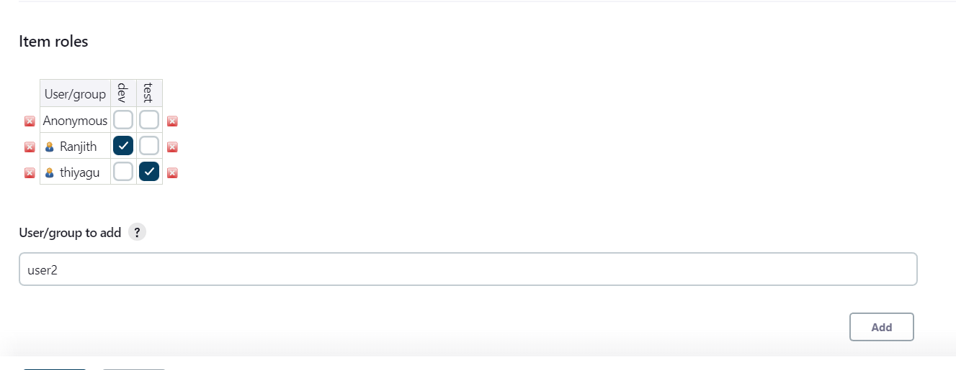

Permission for users, to select matrix-based security

